YELVERTOFT PRE-SCHOOL UNIFORM
ORDER FORM

Child’s Name: | Parent Name:

Item | Price | Size | Quantity | Amount £
Polo Shirt  Age 1-2 / Age 3-4 / Age 5-6 | £7
Sweatshirt  Age 1-2 / Age 3-4 / Age 5-6 | £10
Book Bag | £5 | -
TOTAL AMOUNT DUE

Payment to be made by: (please tick one)
❑ Cash
❑ Cheque
❑ Bank Transfer
(Bank Details - Name: Yelvertoft Pre-School, Sort Code: 54-41-00, Account No: 43238815, Ref: Childs Name)

Yelvertoft Pre-School Sweatshirt  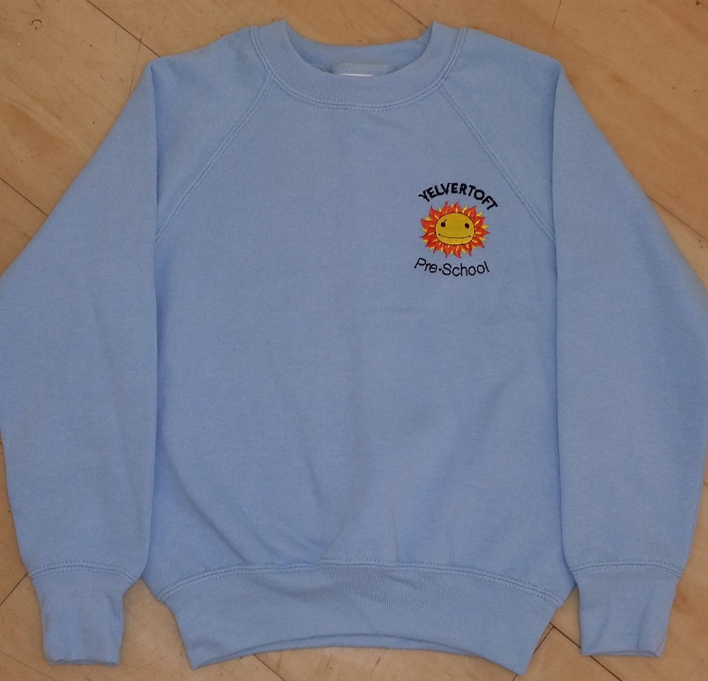 | Yelvertoft Pre-School Polo Shirt  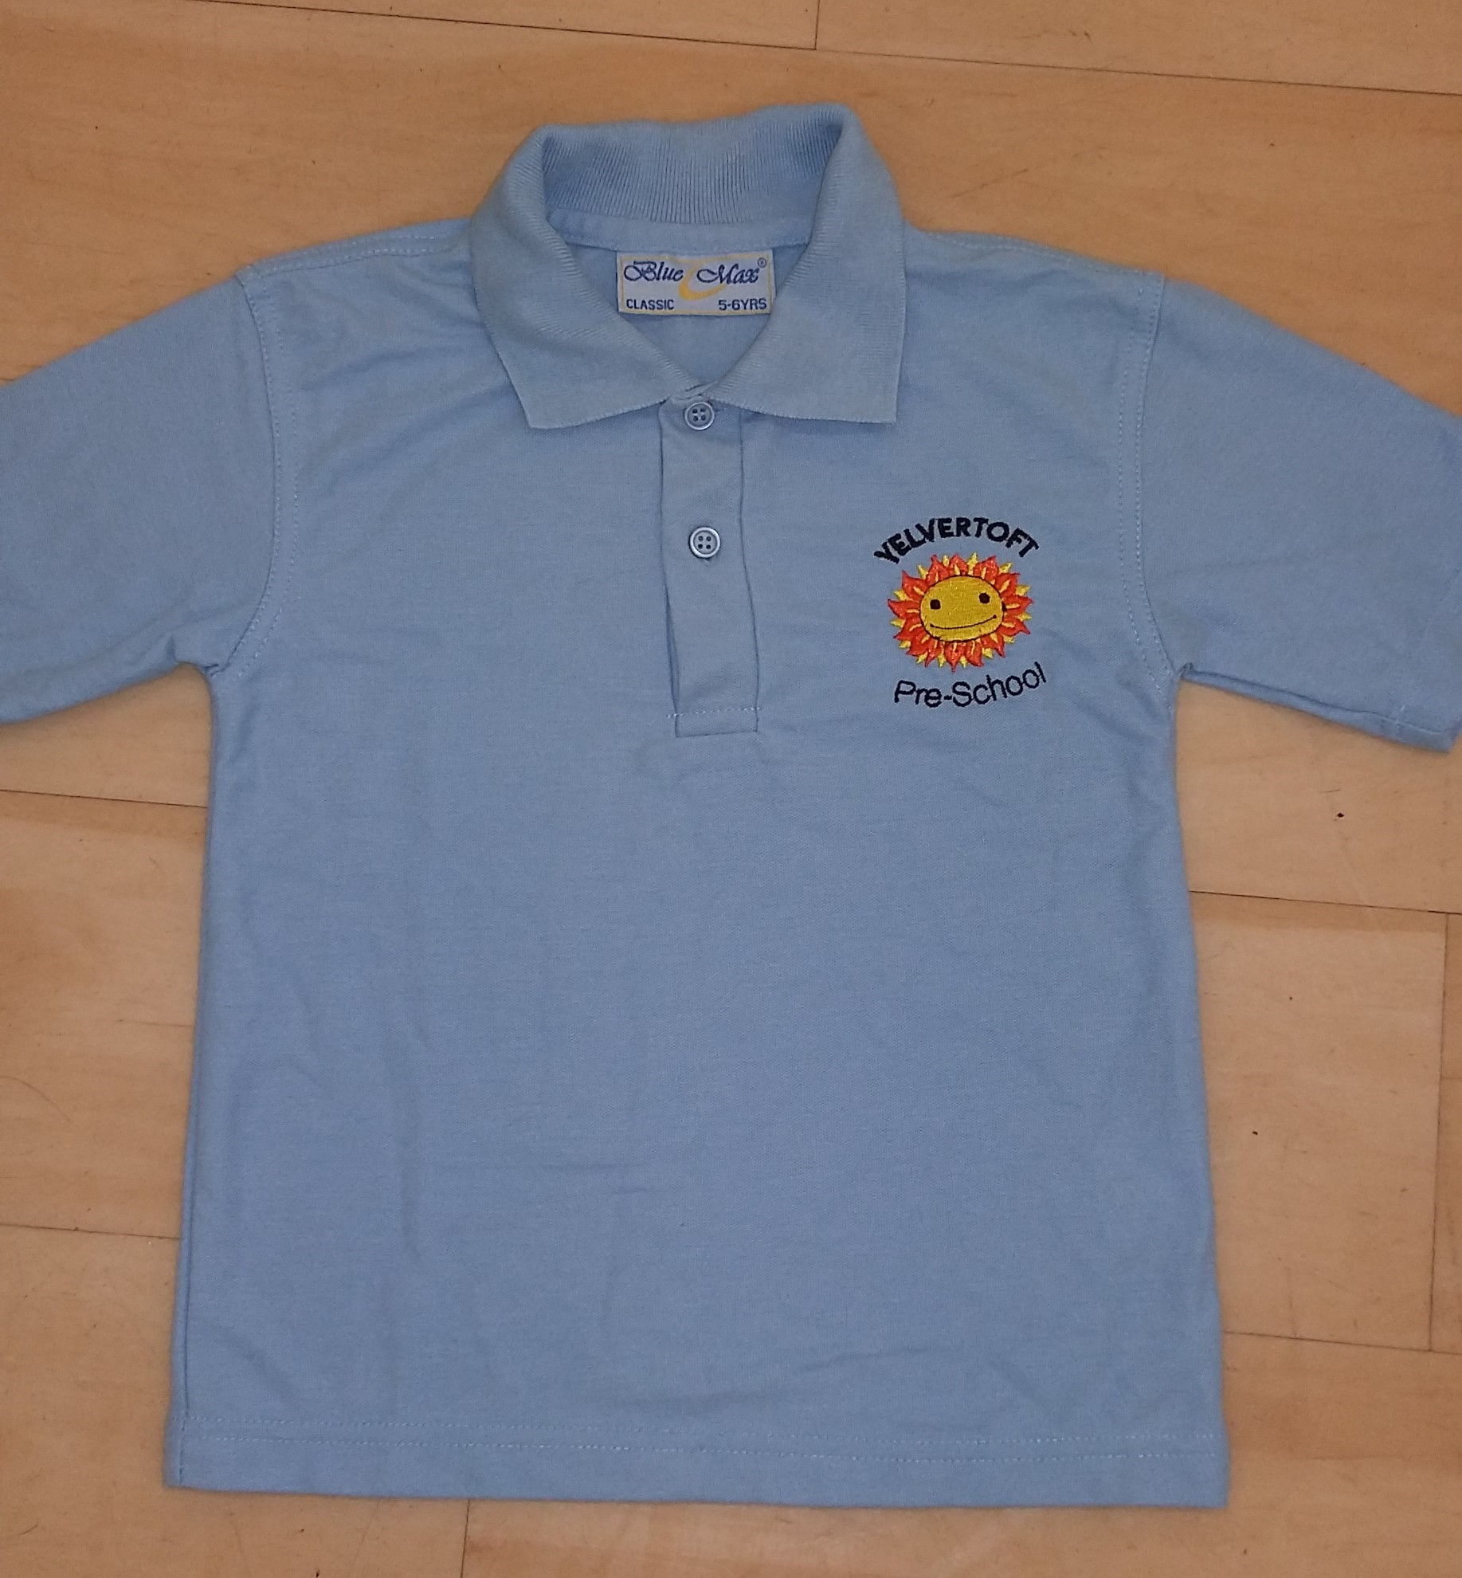
Yelvertoft Pre-School Book Bag

